CLOUDORA PHISHING INVESTIGATION
Using Azure Data Explorer and Kusto Query Language (KQL)

Item | Details
Platform | Azure Data Explorer
Cluster | MyFreeCluster
Database | MyDatabase
Tables | CloudoraMsgTrace_CL and CloudoraSignIn_CL
Project focus | Phishing and potential account compromise

1. Introduction
This project demonstrates a practical SOC investigation of a phishing campaign using Azure Data Explorer and Kusto Query Language (KQL). The investigation correlates phishing-message activity with authentication activity to identify users who may have submitted credentials and subsequently had successful sign-ins.
The main idea is simple: find who clicked a phishing link, determine who submitted credentials, and then examine the affected users' sign-in activity for suspicious indicators.

2. Objectives
- Load and verify phishing-message and sign-in datasets.
- Analyze phishing delivery and authentication results.
- Identify phishing clicks and credential submissions.
- Correlate affected users with successful sign-ins.
- Investigate the suspicious IP address 198.18.7.200.
- Summarize findings and recommend SOC response actions.

3. Tools and Data
Tool/Data | Purpose
Azure Data Explorer | Security-data storage and investigation platform
KQL | Filtering, summarizing, sorting and correlating events
CloudoraMsgTrace_CL | Phishing/message trace events
CloudoraSignIn_CL | User sign-in/authentication events
CSV files | Source data used for ingestion

4. Investigation Process
The investigation was performed in stages so that the large dataset could be narrowed to the most relevant security events.

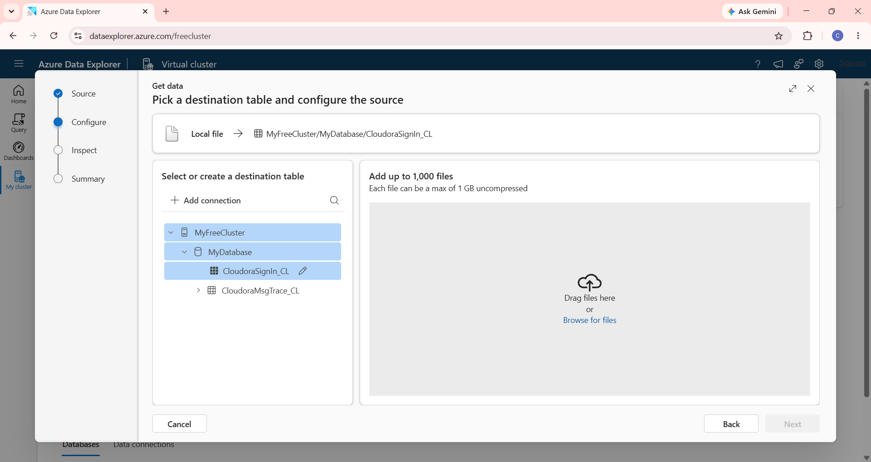

Figure 1. Azure Data Explorer destination-table configuration for the CloudoraSignIn_CL dataset.

The screenshot shows the local CSV ingestion workflow configured to load the sign-in data into MyFreeCluster/MyDatabase/CloudoraSignIn_CL.
- Verify the message dataset count.
- Summarize delivered messages by campaign and authentication results.
- Filter for phishing click events.
- Identify clicks where credentials were submitted.
- Search successful sign-ins for those users.
- Investigate the shared suspicious IP and associated applications.

5. Results and KQL Evidence

5.1 Total message records
CloudoraMsgTrace_CL
| count
Result: 67 records. This confirmed that the message-trace dataset was loaded successfully.

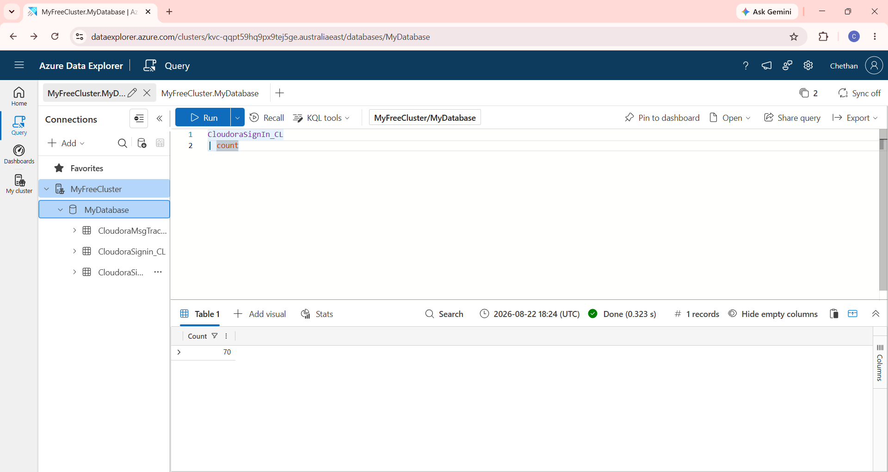

Figure 4. Verification query for the CloudoraSignIn_CL table.

The count query was executed in Azure Data Explorer to verify that the sign-in table contained imported records; the displayed result is 70 records.

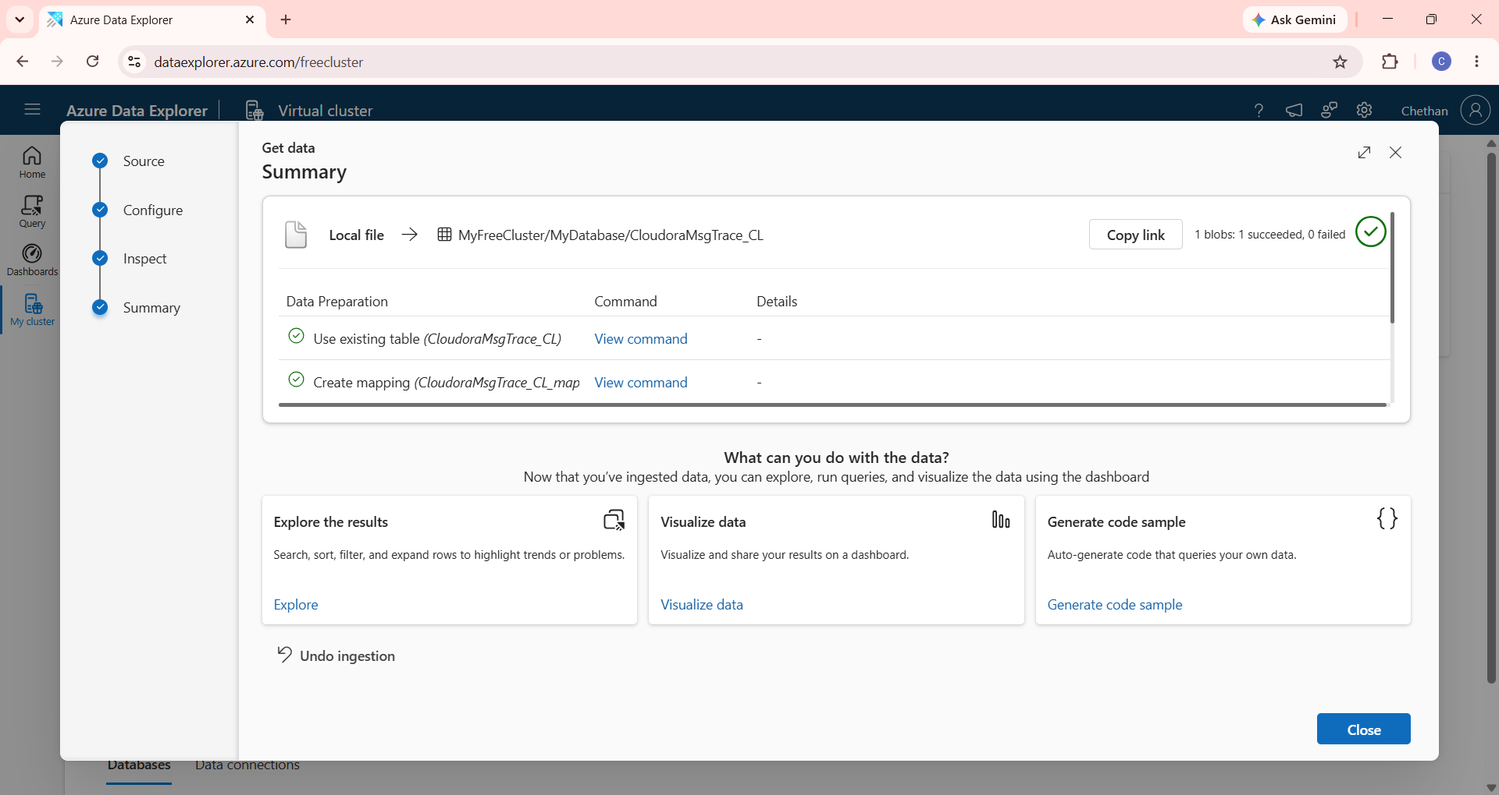

Figure 5. Successful ingestion of the CloudoraMsgTrace_CL dataset.

The Azure Data Explorer ingestion summary confirms that the message-trace file was successfully loaded into the existing CloudoraMsgTrace_CL table and mapped.

5.2 Delivery analysis
CloudoraMsgTrace_CL
| where EventType == "Delivery"
| summarize Messages=count(), Recipients=dcount(RecipientAddress)
by Campaign, SenderIP, SPFResult, DKIMResult, DMARCResult, DeliveryAction
| order by Campaign asc, SenderIP asc
Result: 4 campaign/delivery combinations were returned.

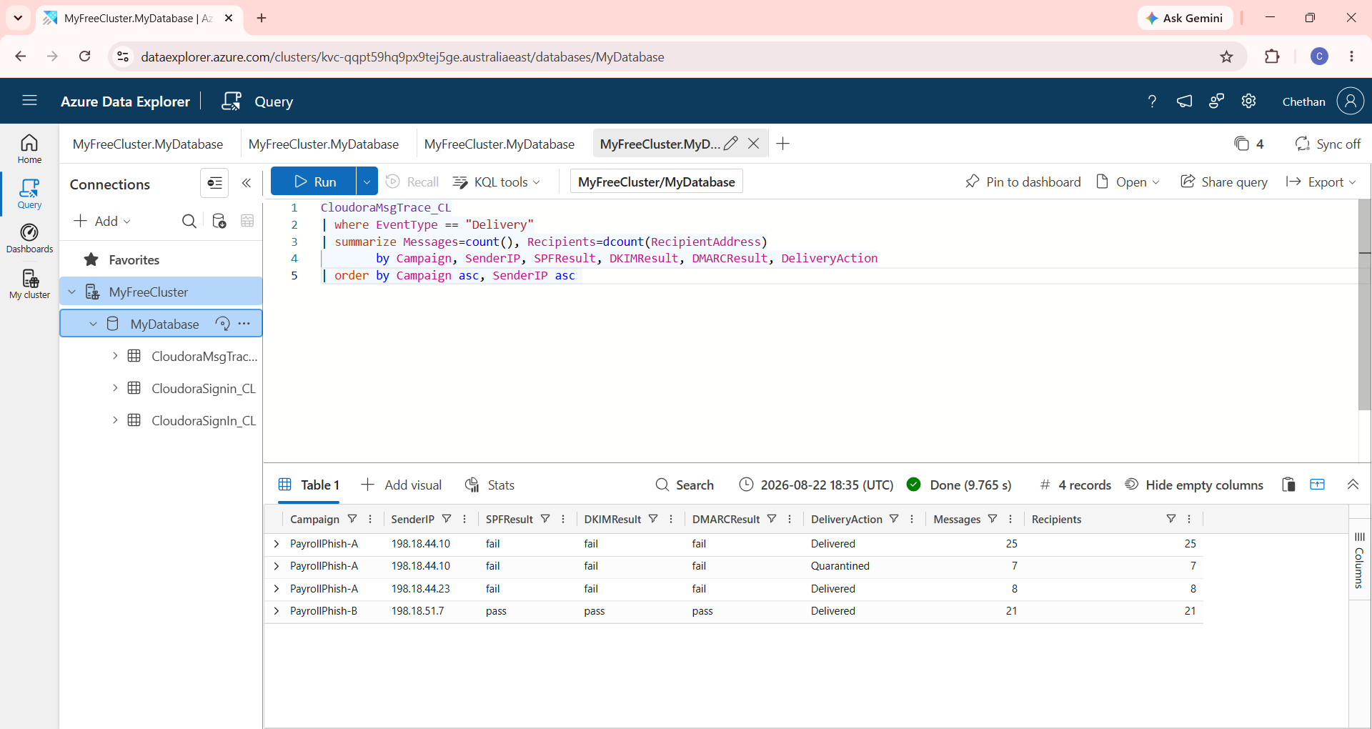

Figure 6. Delivery analysis using Kusto Query Language.

The query groups delivery events by campaign, sender IP and email-authentication results. The output shows failed SPF/DKIM/DMARC for PayrollPhish-A and passing results for PayrollPhish-B, matching the report findings.
Campaign | Sender IP | SPF | DKIM | DMARC | Action | Messages | Recipients
PayrollPhish-A | 198.18.44.10 | fail | fail | fail | Delivered | 25 | 25
PayrollPhish-A | 198.18.44.10 | fail | fail | fail | Quarantined | 7 | 7
PayrollPhish-A | 198.18.44.23 | fail | fail | fail | Delivered | 8 | 8
PayrollPhish-B | 198.18.51.7 | pass | pass | pass | Delivered | 21 | 21

PayrollPhish-A showed failed SPF, DKIM and DMARC results in the displayed delivery summary. PayrollPhish-B showed passing results.

5.3 Phishing click analysis

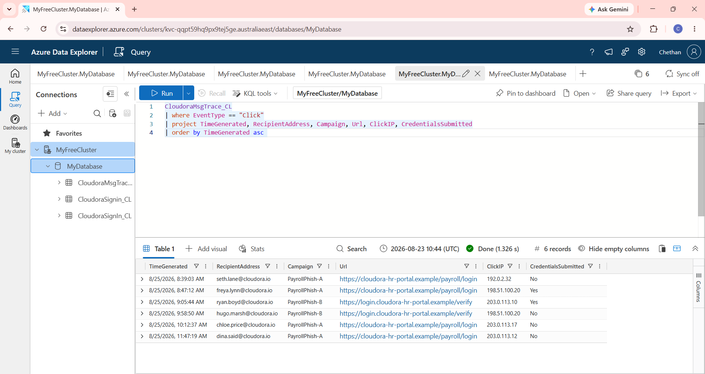

Figure 7. Phishing-click analysis and credential-submission results.

The query isolates Click events and displays the recipient, campaign, URL, click IP and credential-submission status. Six click events are visible, including two users marked Yes for credential submission.
CloudoraMsgTrace_CL
| where EventType == "Click"
| project TimeGenerated, RecipientAddress, Campaign, Url, ClickIP, CredentialsSubmitted
| order by TimeGenerated asc
Result: 6 click events.
User | Campaign | Credentials submitted
seth.lane@cloudora.io | PayrollPhish-A | No
freya.lynn@cloudora.io | PayrollPhish-A | Yes
ryan.boyd@cloudora.io | PayrollPhish-B | Yes
hugo.marsh@cloudora.io | PayrollPhish-B | No
chloe.price@cloudora.io | PayrollPhish-A | No
dina.said@cloudora.io | PayrollPhish-A | No

Two users submitted credentials after clicking: freya.lynn@cloudora.io and ryan.boyd@cloudora.io.

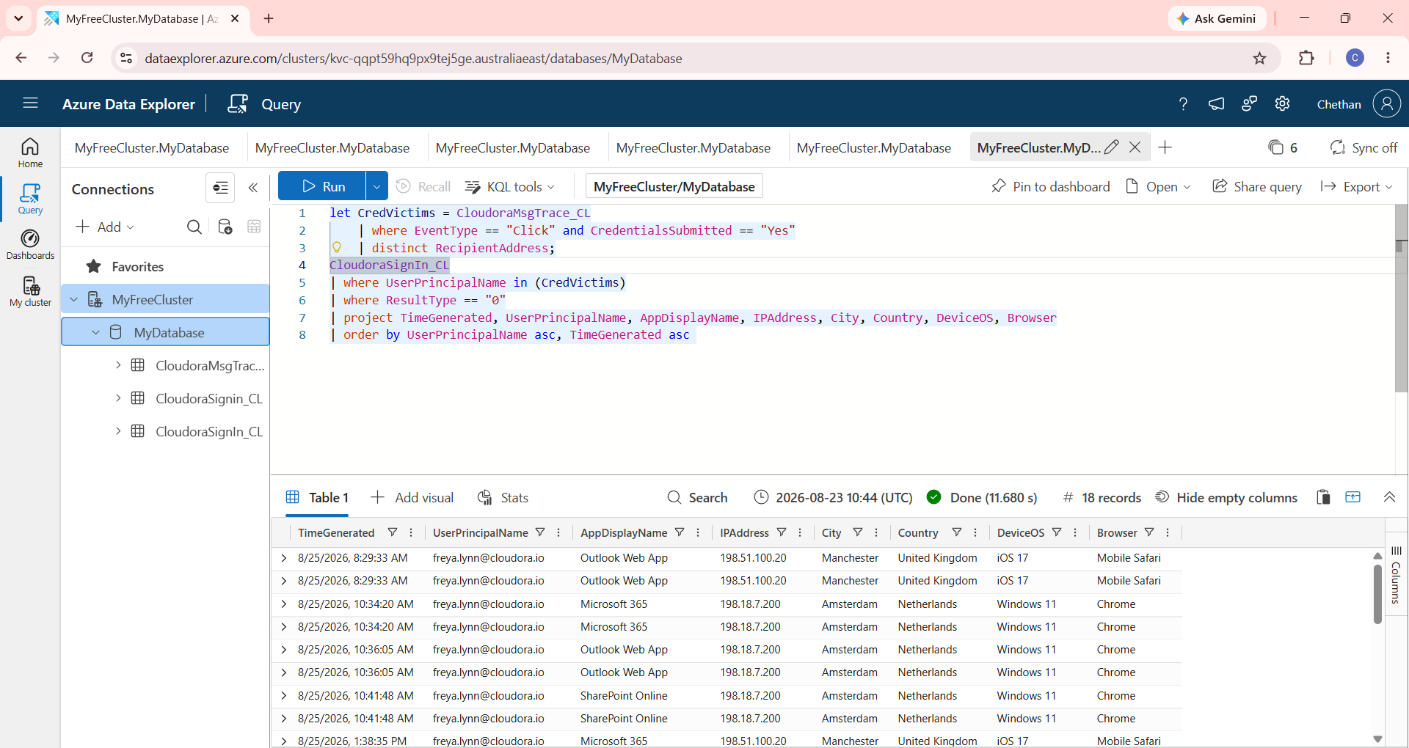

Figure 8. Correlation of credential-submit victims with successful sign-ins.

The query identifies users who submitted credentials and then searches successful sign-in events for those users. The result contains 18 records and exposes IP, location, operating-system and browser information.

5.4 Successful sign-in correlation
let CredVictims = CloudoraMsgTrace_CL
| where EventType == "Click" and CredentialsSubmitted == "Yes"
| distinct RecipientAddress;
CloudoraSignIn_CL
| where UserPrincipalName in (CredVictims)
| where ResultType == "0"
| project TimeGenerated, UserPrincipalName, AppDisplayName,
IPAddress, City, Country, DeviceOS, Browser
| order by UserPrincipalName asc, TimeGenerated asc
Result: 18 successful sign-in records were returned for the credential-submit victims.

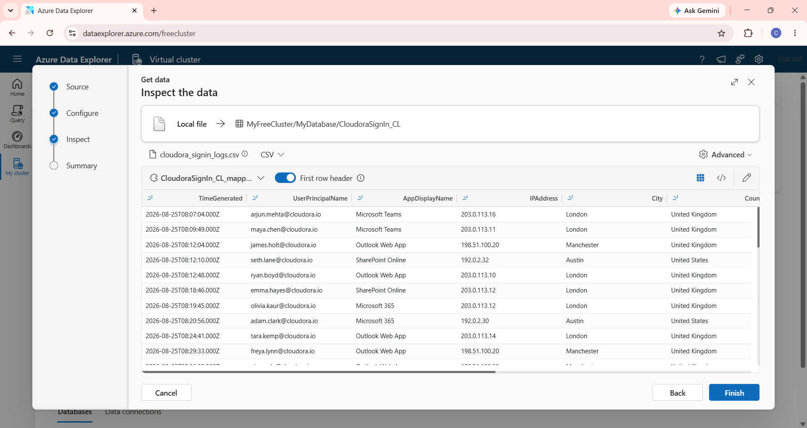

Figure 3. Azure Data Explorer inspection of the Cloudora sign-in dataset.

The Inspect step displays the imported sign-in records and confirms the mapped fields used later for authentication correlation, including TimeGenerated, UserPrincipalName, AppDisplayName and IPAddress.

5.5 Suspicious IP investigation
CloudoraSignIn_CL
| where IPAddress startswith "198.18.7." and ResultType == "0"
| summarize FirstSeen=min(TimeGenerated),
LastSeen=max(TimeGenerated),
Apps=make_set(AppDisplayName)
by UserPrincipalName, IPAddress, Country
| order by FirstSeen asc
Result: 2 records were returned, showing both credential-submit victims associated with 198.18.7.200 in the Netherlands.

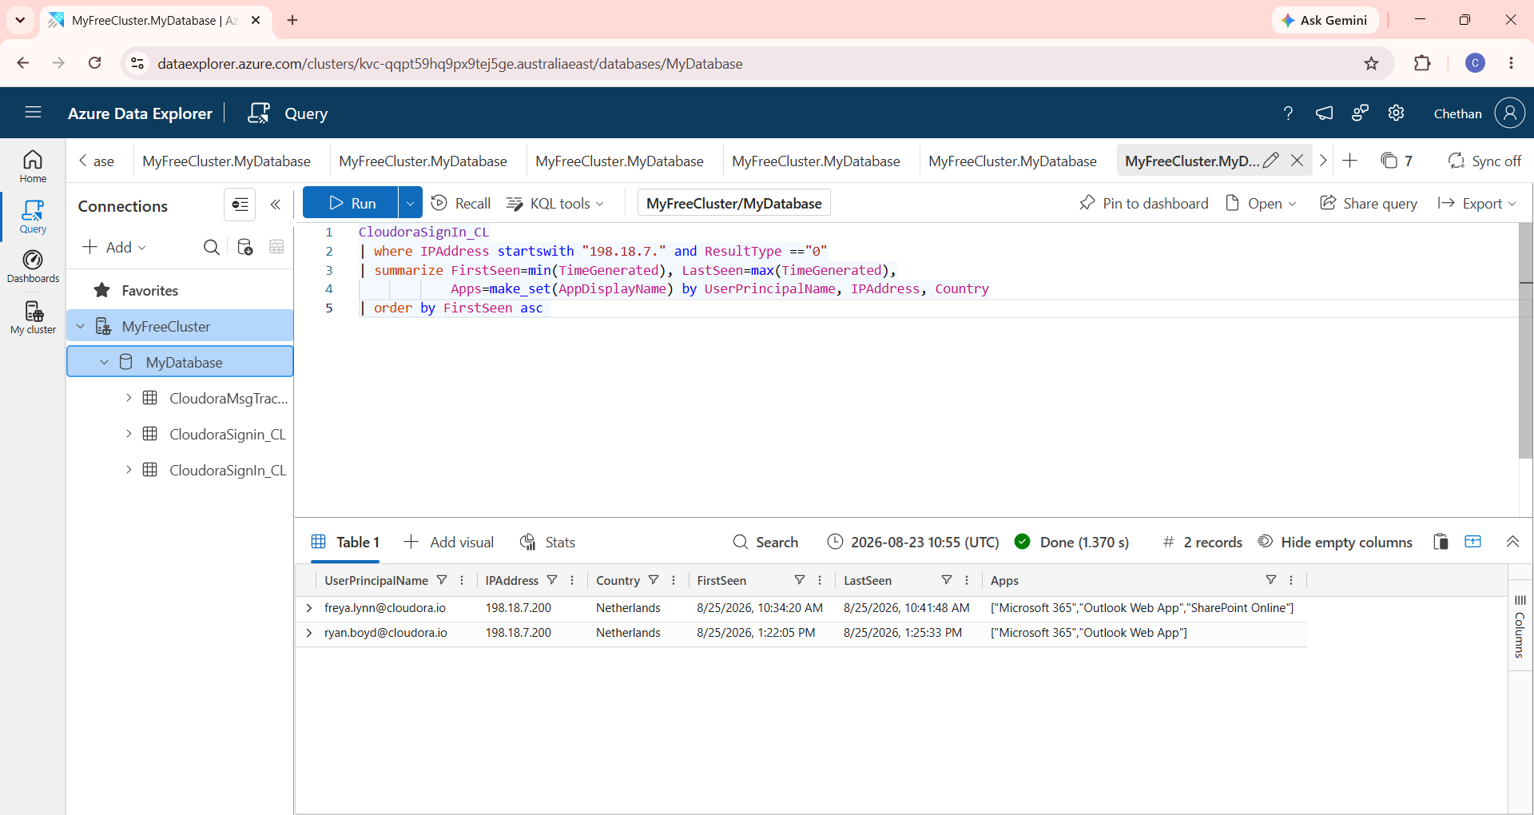

Figure 9. Investigation of the suspicious 198.18.7.x address range.

The query filters successful sign-ins associated with the 198.18.7.x range and summarizes first/last seen times and applications. Two users are returned with IP address 198.18.7.200 in the Netherlands.
User | IP | Country | First seen | Last seen | Applications
freya.lynn@cloudora.io | 198.18.7.200 | Netherlands | 8/25/2026 10:34 AM | 8/25/2026 10:41 AM | Microsoft 365; Outlook Web App; SharePoint Online
ryan.boyd@cloudora.io | 198.18.7.200 | Netherlands | 8/25/2026 1:22 PM | 8/25/2026 1:25 PM | Microsoft 365; Outlook Web App

6. Key Findings
- 67 message-trace records were present.
- 6 phishing click events were identified.
- 2 users submitted credentials after clicking phishing links.
- The affected users were freya.lynn@cloudora.io and ryan.boyd@cloudora.io.
- 18 successful sign-in records were found for the credential-submit victims.
- Both victims were associated with 198.18.7.200 in the Netherlands.
- Freya's observed applications included Microsoft 365, Outlook Web App and SharePoint Online.
- Ryan's observed applications included Microsoft 365 and Outlook Web App.
- PayrollPhish-A showed failed SPF, DKIM and DMARC results in the delivery analysis.

7. Security Interpretation
The combined evidence is consistent with a potential phishing-related account compromise: two users clicked phishing links and submitted credentials, followed by successful sign-in activity associated with the same IP address, 198.18.7.200, in the Netherlands.
The IP address and country should be treated as investigation indicators rather than proof of maliciousness by themselves. A SOC analyst should validate expected user locations, VPN/proxy use, device history and additional security telemetry before declaring a confirmed compromise.

8. Recommended SOC Response
- Reset passwords for affected accounts according to the organization's incident-response procedure.
- Revoke active sessions/tokens for potentially compromised accounts.
- Review MFA activity and strengthen MFA where necessary.
- Investigate 198.18.7.200 and related authentication activity.
- Review Microsoft 365, Outlook and SharePoint activity for unauthorized actions.
- Search other users and endpoints for the same phishing URLs, sender infrastructure and IP indicators.
- Block confirmed malicious phishing infrastructure.
- Continue monitoring affected accounts for unusual authentication activity.

Visual Evidence Integration. The screenshots above provide visual evidence of the Azure Data Explorer ingestion, KQL execution and result tables used throughout the investigation. They are included as supporting evidence alongside the corresponding narrative and KQL results.

9. Conclusion
This project demonstrated how Azure Data Explorer and KQL can be used to investigate a phishing incident by correlating message and sign-in data. The investigation narrowed 67 message records to 6 phishing clicks, then identified 2 users who submitted credentials. Their successful sign-in activity included use of 198.18.7.200 in the Netherlands.
The main lesson is that security events become more useful when correlated across datasets. The results provide a clear investigation lead for a SOC team to validate, contain affected accounts and search for additional related activity.

10. Investigation Flow
67 message records
↓
6 phishing clicks
↓
2 credential-submit victims
↓
18 successful sign-ins
↓
198.18.7.200 / Netherlands
↓
Potential phishing-related account compromise

11. Final Correlation Query

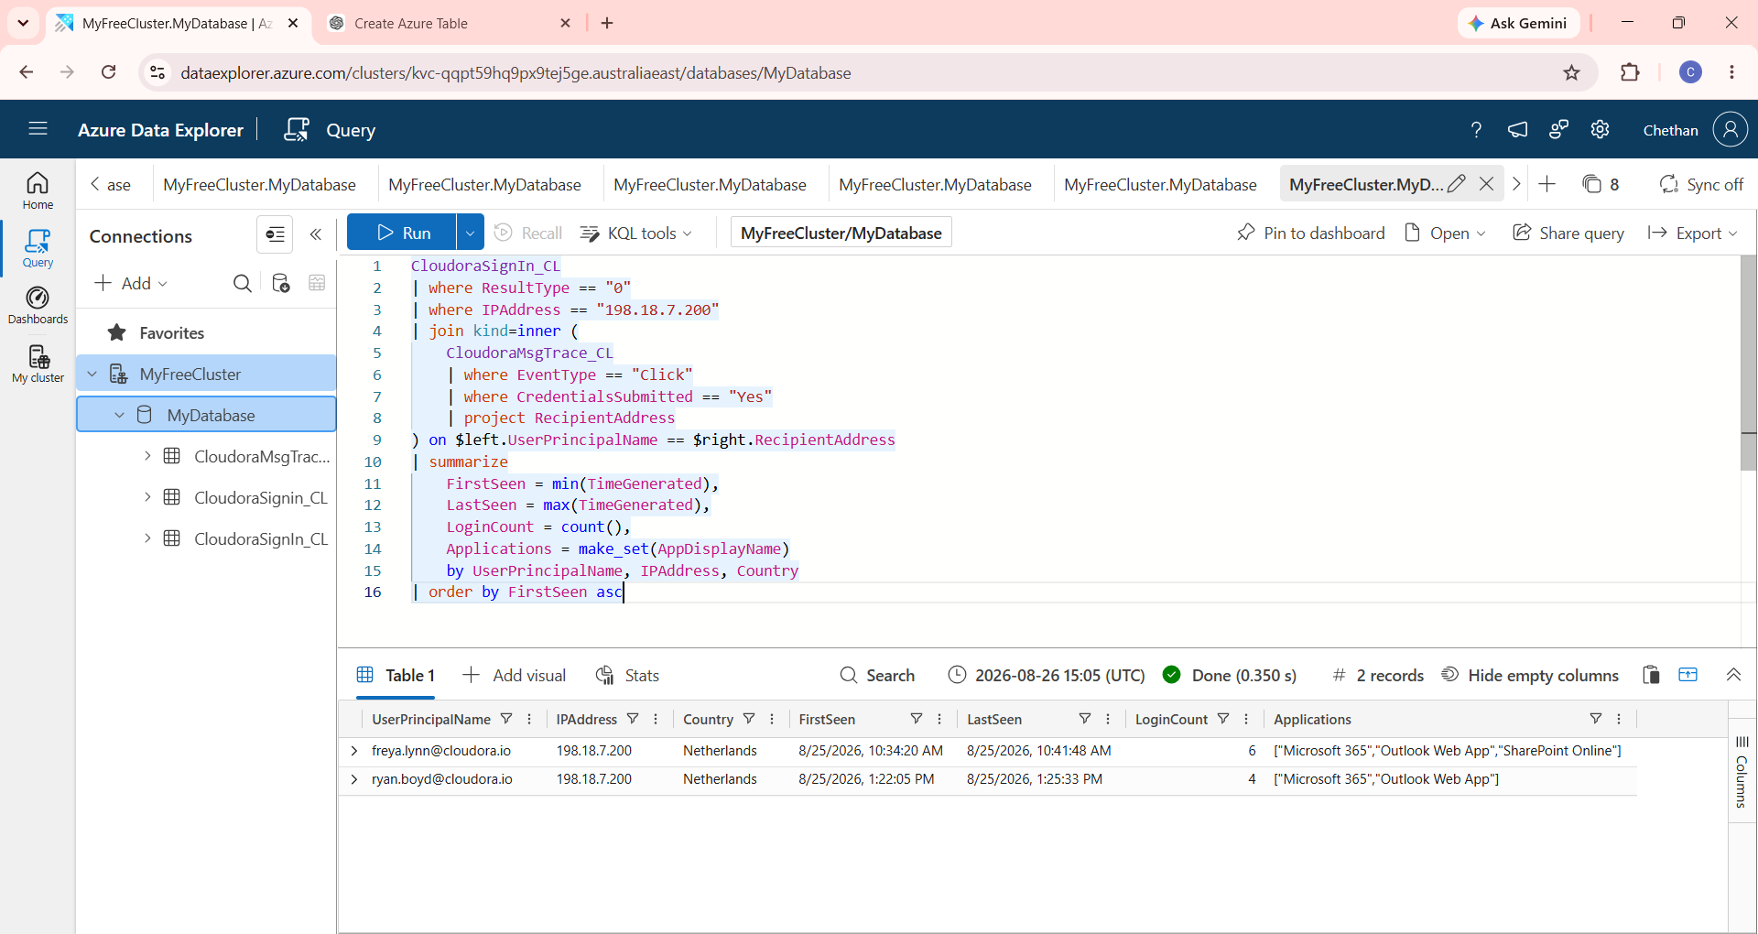

Figure 10. Final correlation query linking phishing credential submission to the suspicious IP.

The final KQL query joins successful sign-ins from 198.18.7.200 with phishing click events where credentials were submitted, then summarizes the first/last seen times, login count and applications for each affected user.
let CredVictims =
CloudoraMsgTrace_CL
| where EventType == "Click" and CredentialsSubmitted == "Yes"
| distinct RecipientAddress;
CloudoraSignIn_CL
| where UserPrincipalName in (CredVictims)
| where ResultType == "0"
| where IPAddress == "198.18.7.200"
| summarize
FirstSeen = min(TimeGenerated),
LastSeen = max(TimeGenerated),
LoginCount = count(),
Applications = make_set(AppDisplayName)
by UserPrincipalName, IPAddress, Country
| order by FirstSeen asc
Note: Use the exact sign-in table name present in your database. In this report, CloudoraSignIn_CL is the table containing the required UserPrincipalName and authentication fields.

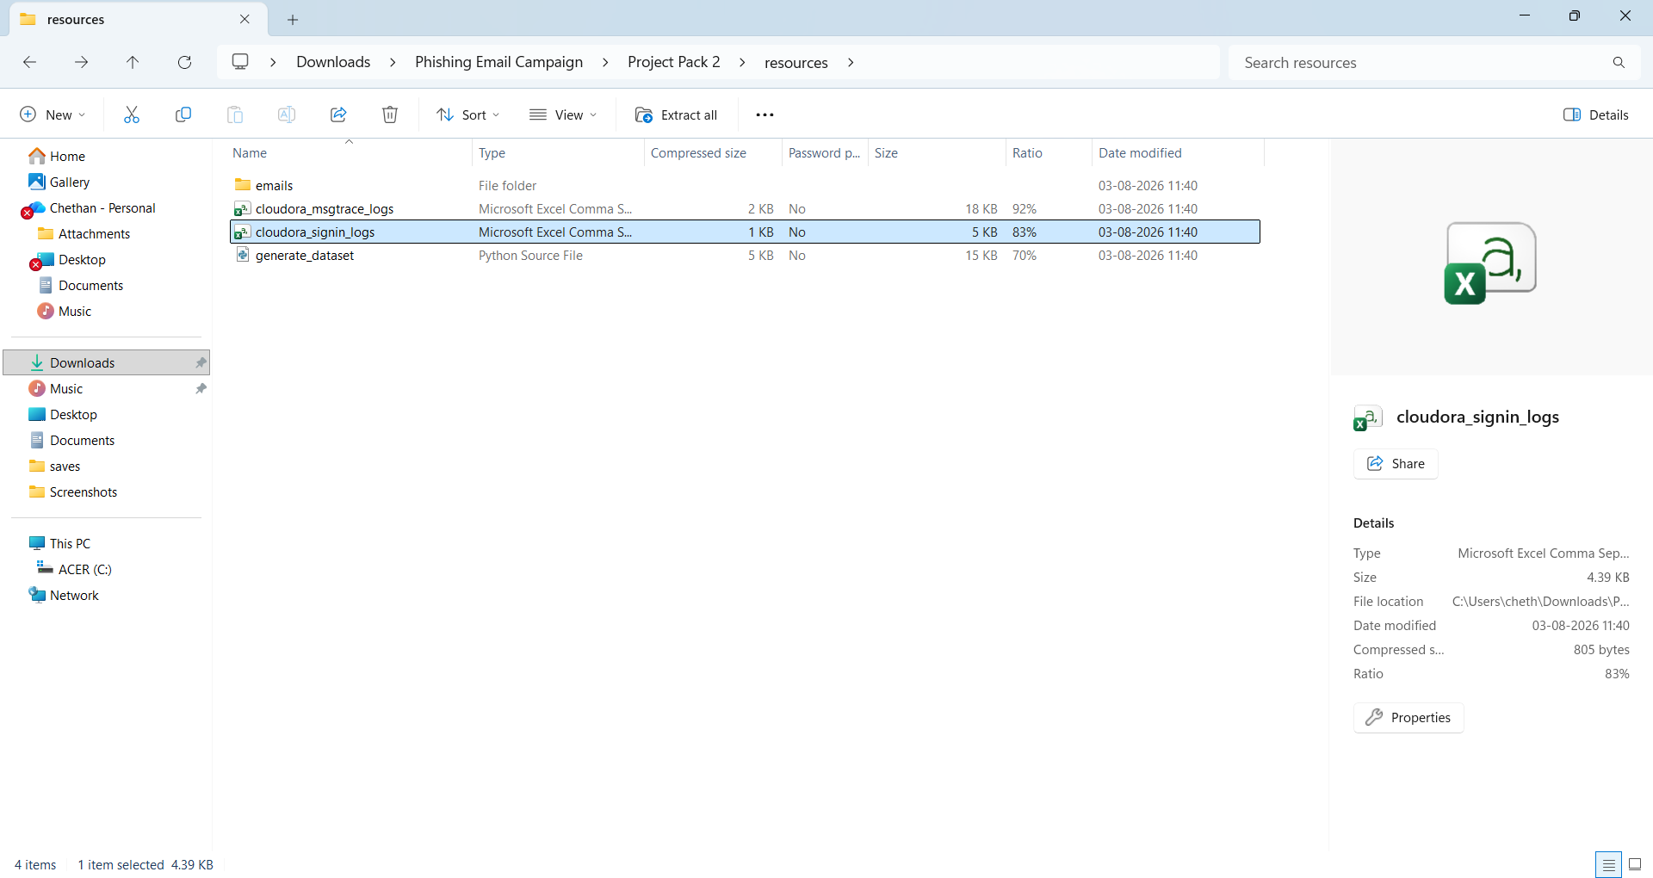

Figure 2. Source files prepared for the Cloudora phishing investigation.

The project resources folder contains the Cloudora message-trace logs and sign-in logs used as source data for the investigation.

